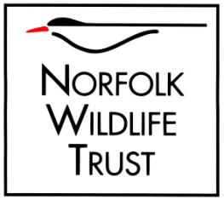

250 Club Application Form

Number of tickets requested (at £12 per year each)

What name/s should the ticket/s be held in? – must be over 16 and UK residents

Gift tickets: Please mark clearly if any of these are to be gifts.

On winning prizes, to whom should cheques be made out? – must match a valid bank account, i.e. do not enter joint names if single accounts are held.

Payer’s Address - this must be a UK address

Gift tickets: We can either send winnings to you or to the gift recipient – please also advise their address if you wish us to send winnings direct to the gift recipient..

Your e-mail address:

Where did you hear about the 250 Club?

Please
Save, and Send by email to 250club@norfolkwildlifetrust.org.uk

OR
Print and send to
250 Club, Norfolk Wildlife Trust, Bewick House, 22 Thorpe Road, Norwich, NR1 1RY

Privacy Notice
We will keep your details secure at all times. We will use your details to administer your subscription and send you 250 Club information. We never sell or share your details with any other third party for their own use. This is our summarised Privacy Notice. For our full Privacy Policy please visit www.norfolkwildlifetrust.org.uk/privacy

