RAPID POND SURVEY GUIDANCE NOTES

For pond survey, see page 6. Guidance on many aspects of pond survey work can be found in the Freshwater Habitats Trust 2015 Pond Habitat Survey Method Booklet (the ‘FHT booklet’).

Pond name/number, Landholding name, Site owner/contacts:
Add appropriate details.

Grid reference:
Refer to section 2.1 of the FHT booklet.

Location notes:
Land use: Describe main adjacent land use(s) e.g. arable/grassland/urban/woodland etc.
Buffer width: Provide width of any buffering vegetation before main adjacent land use if possible.
In/outflows: Note any pipes feeding into or out of pond and where they seem to be coming from e.g. a ditch, road, arable field etc. Refer to section 2.15 of the FHT booklet.
Runoff: Note what is ‘uphill’ of the pond that may be a source of run off e.g. arable field, road, ditch etc.
Pollution / waste: Record any obvious signs of pollution (e.g. sewage) or other waste (e.g. fly tipping)
Recent management: Note any obvious signs of recent pond management e.g. trees cleared, pond slubbed out etc. Refer to section 2.13 of the FHT booklet.
Hazards (power lines, pipes): Note any seen in the immediate vicinity of pond that may affect management.

Length x Width (metres):
Size of pond when at high water level. Refer to section 2.5 of the FHT booklet.

Soft mud depth:
Estimate, if possible, by pushing a cane/stick gently down into the pond base. Do not enter the pond to do this.

Current water depth at time of visit:
Estimate, if possible, using a cane/stick.

Maximum water level above current water (cm):
Estimate how far above the current water level the pond will reach at its maximum water level. Refer to section 2.11 of the FHT booklet (where it is called the ‘drawdown’ height).

Temporary/Permanent pond:
Refer to section 2.6 of the FHT booklet.

% Pond surrounded by trees:
Looking out from the pond on all sides, provide best estimate of the % of the pond surrounded by trees e.g. if pond is surrounded by a full hedge then 100%, if just one big oak by pond it may be, say 2-5% (this is not referring to the shading of the pond – see below).

% Shading of pond: % of the pond, and % or pond margin, shaded by surrounding trees. Refer to section 2.7 of the FHT booklet.

% Emergent plants, % Floating plants, % Submerged plants:
Record the % of the whole high-water pond area covered by emergent plants. Record the % of the current wet area covered by floating and submerged plants. Refer to section 2.10 of the FHT booklet.

Water colour: clear/green/ brown/black/grey:
Describe general appearance.

Trees/scrub/hedge, species, size, location, health:
Describe vegetation immediately surrounding pond. Include species if known, size/height and health (i.e. in full leaf, partial leaf, presence of dead wood, large fungi etc.).

General notes on wildlife:
Fish presence: Refer to section 2.8 of the FHT booklet.
Waterfowl presence: Refer to section 2.9 of the FHT booklet.
Invertebrates, mammals, amphibians etc.: Note any seen if possible.
Indicator flora, Reed/Bulrush, Invasive species:
Note any seen from list provided. Note % cover of reed and bulrush if present.

Example of pond shape drawing

Draw picture of  pond shape below  See example in guidance notes below | Key:  O tree  X marginal vegetation  A aquatic vegetation  = pipe in/outflow (add arrow showing flow direction if possible)

Pond indicator species

Marginal plants:

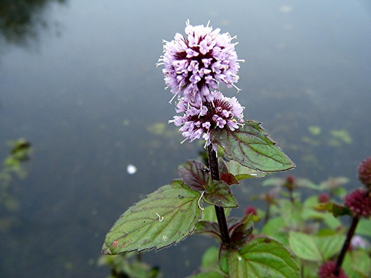 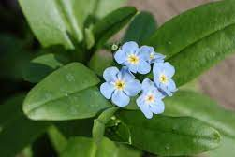 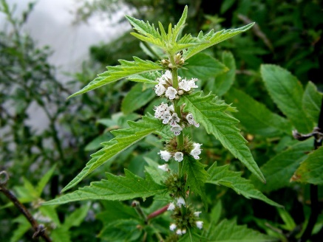 Water mint Water forget-me-not Gypsywort

Aquatic plants:

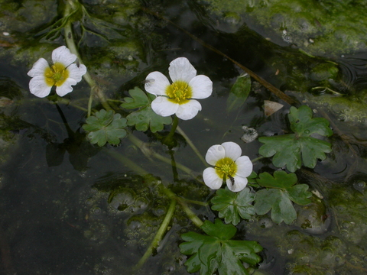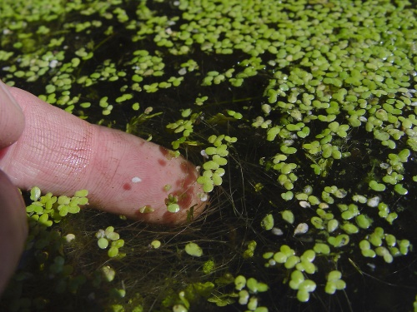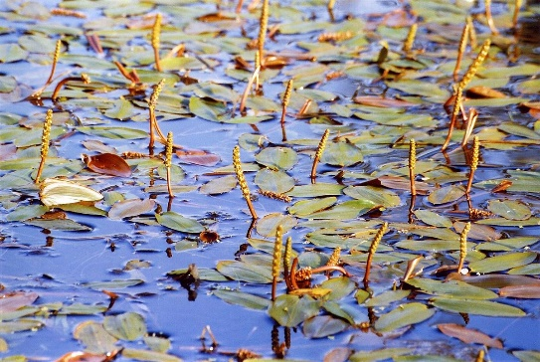
Water crowfoot Duckweed Pondweed

Reed / Bulrush

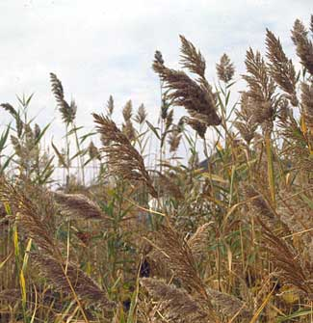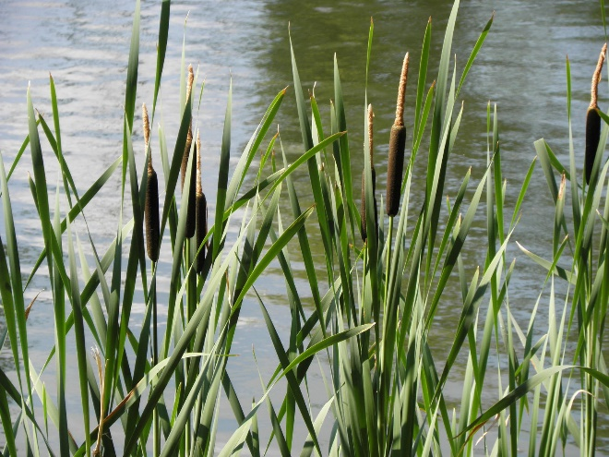
Common reed Bulrush

Invasive plants:

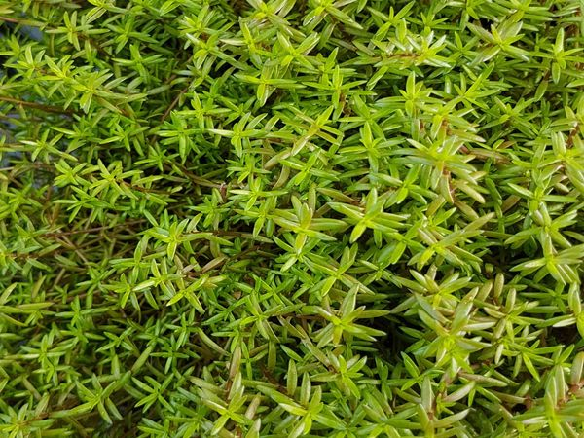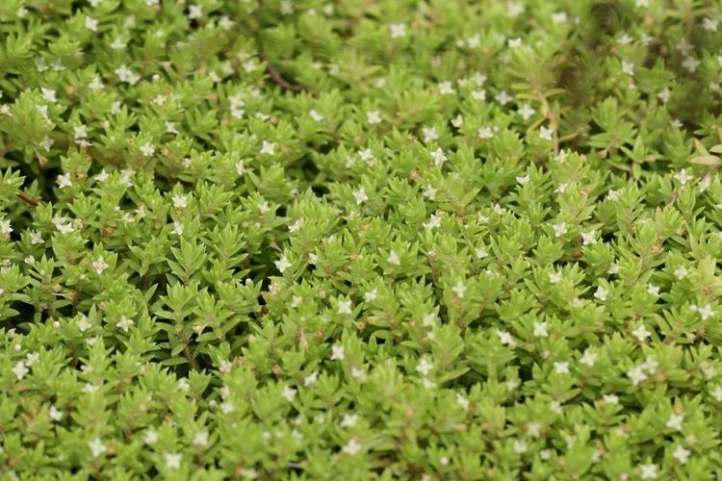
Crassula

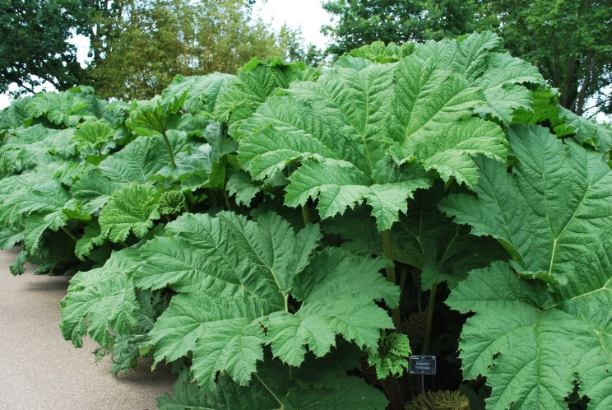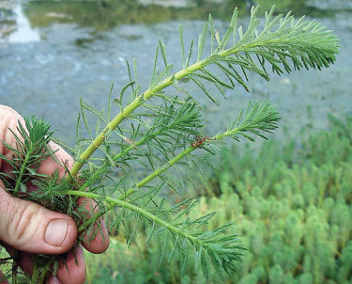
Gunnera Parrot’s feather

RAPID POND SURVEY

Details

Recorder:

Date/time:

Scanned or typed up:

Pond name/number:

Landholding name:

Grid ref:

Photo ref numbers (if provided - max. 2 per pond):

Location notes
(add notable features on sketch map below)

Adjacent land use:

Buffer width:

In/outflows:

Runoff:

Pollution/waste:

Signs of recent management:

Hazards (power lines, pipes etc.)

Pond characteristics:

Length x width of pond (metres):

Soft mud depth (cm):

Water depth at time of visit (cm):

Maximum water level above current water level (cm):

Temporary/permanent pond?:

% pond surrounded by trees: | % Shading of pond:  Pond ___ %  Pond margin ___ % | ___% Emergent plants  ___% Floating plants  ___% Submerged plants
Water colour: clear/green/brown/black/
grey

Trees/scrub/hedge:
species, size, location, health

General notes on wildlife seen:
Fish; ducks, moorhens or other water birds; invertebrates; mammals; amphibians etc.

Indicator flora:  Tick species present (pictures below) | Marginal plants  Water mint □ Water forget-me-not □ Gypsywort □  Aquatic plants  Water-crowfoot □ Duckweed □ Pondweed □
Reed / bulrush cover % | Common reed ___% Bulrush ___%
Invasive species:  if present tick box and add brief details e.g. % cover (see pictures below) | Crassula □ Gunnera □ Parrot's feather □

Draw picture of pond shape below  See example in guidance notes below | Key:  O tree  X marginal vegetation  A aquatic vegetation  = pipe in/outflow (add arrow showing flow direction if possible)

