Volunteer Role Description 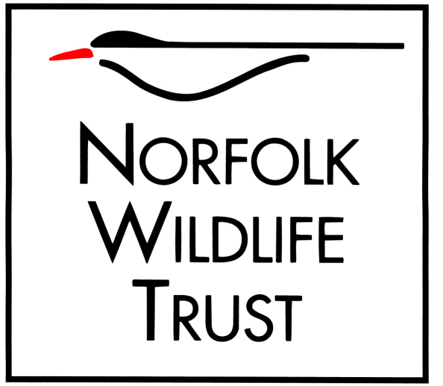

Role title
Volunteer Reserve Assistant – NWT West Norfolk
Purpose of your role
To assist the reserve team with the management of NWT’s West Norfolk nature reserves for the benefit of wildlife and visitors

Type of work you will be involved with
Habitat management including scrub control and fen mowing, using a variety of machinery and hand tools
Maintenance of visitor infrastructure such as track repairs, maintenance of signage, gates, benches and footpaths
Routine patrolling of the reserves to minimise disturbance to breeding birds, other key wildlife and fragile habitats.
Ensure implementation of the Trust's Health & Safety policies
Help supervise other volunteers in the day to day running of the reserve
Brushcutter, chainsaw and pesticide use - only where suitable training and certification has been received

Skills and abilities you will be using in your role
Whilst we do not expect new volunteers to have existing experience or skills in practical habitat and infrastructure management/maintenance, existing skills/knowledge is desirable. Training will be provided where appropriate.
Excellent interpersonal skills, ability to deal with a wide range of visitors in a tactful and diplomatic manner.
Some interest, knowledge and understanding of the habitats and wildlife of the area will be of benefit.
Resourceful, able to plan, implement and undertake a wide variety of tasks with minimal supervision
Physically fit and in good health in order to carry out work to required standards
Ability to use and maintain reserves equipment and machinery to appropriate standards (or willing to train)
Ability to supervise and motivate other volunteers working on the reserve.
Maintain confidentiality.
Health & Safety awareness and common sense.
You will be based at
Roydon Common with visits to other local sites such as East Winch Common, Narborough Railway Line, Ringstead Downs and Syderstone Common.
Times/days we would like you to be available
Wednesday 8.30am to 13:00 (half day) or to 16:00 (full day)
Benefits to you
Opportunities to develop practical management skills
On the job training relevant to tasks undertaken
Become a valued member of a professional team
Knowledge that the work you do will benefit internationally important nature reserves and the work of NWT
Opportunity to learn/enhance/share local knowledge of wildlife and conservation
Gain experience in a variety of different activities

Your supervisor
Ash Murray – West Norfolk Reserves Manager and Anne Simpson – West Norfolk Deputy Reserves Manager

Notes/special requirements
Must be prepared to work outside in all weather conditions
May be required to work unsocial hours (early mornings and evenings)
May be required to assist with management of other land as directed by the reserve staff

